PH126 Logic I Fast Lecture 5
Lecturer: s.butterfill@warwick.ac.uk

Multiple quantifers
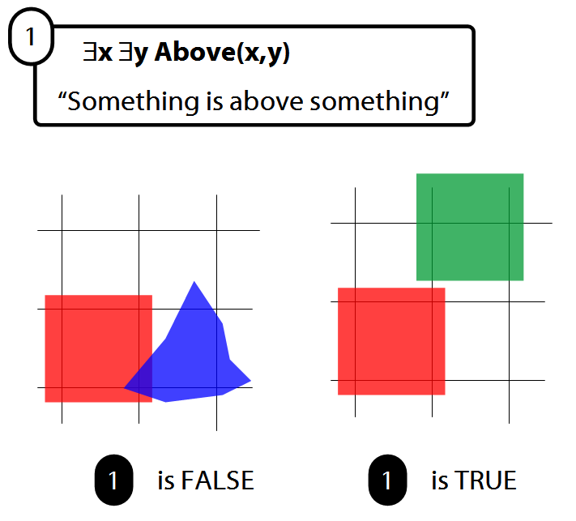

There is a store for everything
∃y∀x StoreFor(y,x)
∀y∃x StoreFor(x,y)
Other sentences to translate:
Wikipedia has an article about everything
Everyone hurts someone they love
Someone hurts everyone she loves

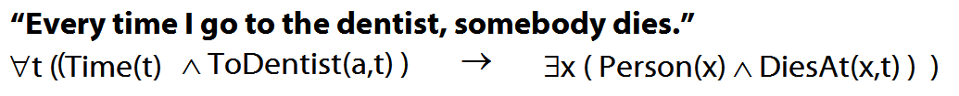
Quantifiers bind variables
Read §9.2 of Barwise & Etchemendy
Two objects are broken
∃x ∃y ( Broken(x)∧Broken(y)∧¬(x=y) )
To translate sentences involving number into FOL, use identity.

The Soundness & Completeness Theorems
‘A├ B’ means there is a proof of B using premises A
‘├ B’ means there is a proof of B using no premises
‘A╞ B’ means B is a logical consequence of A
‘╞ B’ means B is a tautology
‘A╞_{T} B’ means B is a logical consequence of A just in virtue of the meanings of truth-functions (the textbook LPL calls this ‘tautological consequence’)

Soundness: If A├ B then A╞ B
I.e. if you can prove it in Fitch, it’s valid

Completeness: If A╞_{T} B then A ├ B
I.e. if it’s valid just in virtue of the meanings

Exercise
If the following is valid, give a formal proof. If it is not valid, give a counterexample.
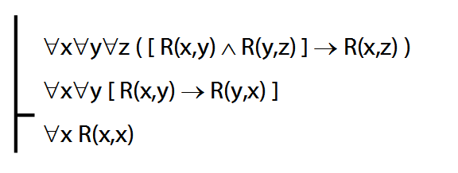

Reflexive, symmetric and transitive

A reflexive relation is one that everything bears to itself. (E.g. SameShape)
∀x R(x,x)
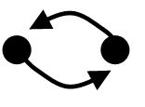
A symmetric relation is one such that if x bears it to y, then y bears it to x. (E.g. Adjacent(x,y).)
∀x∀y ( R(x,y) → R(y,x) )
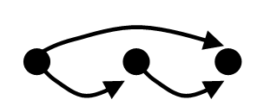
A transitive relation is one such that if x bears it to y and y bears it to z then x bears it to z. (E.g. LeftOf is transitive; DifferentShape is not transitive) ∀x∀y∀z ( [ R(x,y) ∧ R(y,z) ] → R(x,z) )
Quantifier equivalences
P→Q ╡╞ ¬Q→¬P
∀x ( Square(x) → Broken(x) )
╡╞ ∀x (¬Broken(x) → ¬Square(x) )

P→Q ╡╞ ¬P∨Q
∀x ( Square(x) → Broken(x) )
╡╞ ∀x (¬Square(x) ∨ Broken(x) )

¬P∨Q ╡╞ ¬(P∧ ¬Q)
∃x ¬F(x) ╡╞ ¬∀x F(x)
∀x (¬Square(x) ∨ Broken(x) )
╡╞ ∃¬x ( Square(x) ∧ ¬Broken(x) )

∃x ¬Created(x) ╡╞ ¬∀x Created(x)
Truth-functional completeness (LPL §7.4)
How many truth-functions can be constructed using 2 sentence letters?
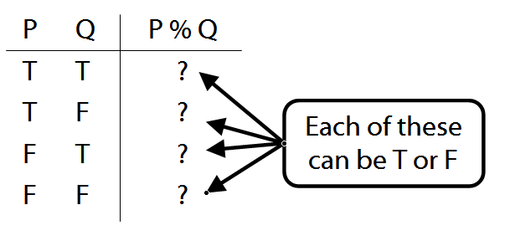
Df. ‘A set of truth-functors is said to be expressively adequate (or sometimes functionally complete) iff, for every truth-function whatever, there is a formula containing only those truth-functors which express that truth-function, i.e. which has as its truth-table the truth-table specifying that function.’ (Bostock, Intermediate Logic p. 45)
Illustration of the proof that {¬, ∧, ∨} is truth-functionally complete:
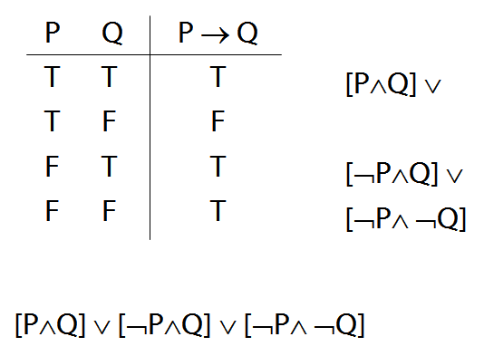

Exercise assuming {¬,∨,∧} is truth-functionally complete, show that {¬,∨} is.

Exercises 06
For your sixth seminar
Only for fast groups
A. From the LPL textbook:
11.2, 11.4
11.8, 11.9, *11.11
13.12, 13.14, 13.16 (quantifier proofs)
13.28
Despite what book says, DON’T even THINK about using TAUT CON.
B. For each of the following sentences of FOL, give a logically equivalent sentence of idiomatic English using the specified interpretation. Your English sentences should be as concise as possible.
Domain : people and actions
D(x) : x is desirable
V(x) : x is virtuous
A(x) : x is an action
H(x) : x is a person
P(x,y) : x performed y
i. ∀x [ D(x) → V(x) ]
ii. ∀x [ [A(x)∧ D(x) ] → V(x) ] ]
iii. ∃x [ A(x) ∧ ¬[ D(x) → V(x) ] ]
*iv. ∃x ∀y [[[H(x) ∧ A(y)] ∧ P(x,y)] → V(y)]
**v. ¬∃x [∃y [H(x) ∧ P(x,y) ∧ A(y) ∧ ¬V(y)]
∧ ¬∃z[P(x,z) ∧ A(z) ∧ V(z)]]

